Report On

# 3DMaze Game

Submitted in partial fulfillment of the requirements of the Course project in Semester VII of Final Year Computer Science Engineering(Data Science)

by

Sahil Gujral (Roll No:15)

Jidnyasa Patil(Roll No:43)

Niyati Patil(Roll No:44)

Supervisor

Prof. Sejal Dmello



**University of Mumbai**

**Vidyavardhini's College of Engineering & Technology**

**Department of Artificial Intelligence and Data Science**



**(2023-24)**

**Vidyavardhini's College of Engineering & Technology**

**Department of Artificial Intelligence and Data Science**

**CERTIFICATE**

This is to certify that the project entitled “3D Maze Game” is a bonafide work of "**Sahil Gujral (Roll No.15),Jidnyasa Patil(Roll No.43), Niyati Patil(Roll No.44)”** submitted to the University of Mumbai in partial fulfillment of the requirement for the Course project in semesterVII of Final Year Computer Science Engineering (Data Science).

**Supervisor**

Prof.Sejal Dmello

Dr. Tatwadarshi P. N.

Head of Department

**Table of Contents**

| Chapter  No | Title | Page No. |
| --- | --- | --- |
| **1** | **Abstract** | 1 |
| **2** | **Introduction** | 2 |
| **3** | **Problem Statement** | 3 |
| **4** | **Software and Hardware Requirements** | 4 |
| **5** | **Results** | 5 |
| **6** | **Conclusions** | 6 |

**Abstract**

In the realm of Virtual Reality (VR), the Maze game stands as a testament to the potential of immersive and captivating gameplay experiences. This project delves into the intricacies of VR design and development, utilizing the Unity platform to create an engaging and intuitive 3D Maze game. The focus lies on crafting an immersive user experience that challenges players while maintaining a seamless and intuitive interface.

This report presents an in-depth exploration of VR UX principles and their application in the context of maze game design. By delving into the challenges of translating labyrinthine mechanics into a virtual space, we examine how VR can amplify the thrill and suspense for players, creating an unforgettable gaming experience.

Leveraging the Unity development environment, the report delves into the technical aspects of VR game development, encompassing asset integration, physics simulations, and user interface design. The aim is to construct a visually captivating maze environment that promotes exploration and engagement, all while ensuring a user-friendly interface for seamless navigation.

Furthermore, the report delves into the significance of user testing and feedback incorporation, highlighting the iterative nature of UX design. It underscores the importance of user feedback in refining the game mechanics and interface to ensure a stimulating and fluid experience.

The project culminates in the creation of a fully functional VR 3D Maze game, showcasing the immersive potential of VR in traditional gaming. By challenging players with complex pathways and dynamic environments, the game not only entertains but also highlights the power of VR in transforming classic gaming concepts into unforgettable adventures.

**Introduction**

Virtual Reality (VR) has emerged as a transformative technology, promising immersive and interactive experiences across diverse applications. This project delves into the realm of VR to design and develop an engaging 3D maze game using Unity. The goal is to explore the intricate aspects of user experience design in VR, leveraging the capabilities of Unity to create an immersive and intuitive maze-solving adventure.

This report outlines the journey of conceptualizing, designing, and implementing a VR 3D maze game, with a primary focus on user experience and interaction design. We delve into the critical steps involved in crafting a VR experience that offers both entertainment and usability. Key components, such as spatial audio, hand-tracking, and motion controls, are harnessed to provide a realistic and thrilling gameplay experience.

The project begins with a comprehensive analysis of VR UX principles and best practices, establishing the foundation for the design process. We explore the challenges of translating real-world maze navigation into virtual space and examine how VR can enhance the immersion factor for players.

The Unity development environment serves as the primary platform for constructing the 3D maze game. We discuss the technical aspects of VR development in Unity, including asset integration, physics simulations, and user interface design, to create a visually captivating and user-friendly environment for maze exploration.

Additionally, the report delves into user testing and feedback collection, emphasizing the iterative nature of UX design. It highlights the importance of user feedback in refining the game mechanics and interface for a seamless and thrilling experience.

The project culminates in a fully functional VR 3D maze game that demonstrates the principles of immersive UX design. The game not only offers a captivating maze-solving adventure but also showcases the potential of VR in transforming traditional gaming into a breathtaking and immersive journey.

**Problem Statement**

The problem at hand is to develop a Virtual Reality (VR) 3D Maze game that seamlessly blends immersive gameplay with an intuitive user experience, overcoming challenges related to translating traditional maze mechanics into the virtual space, and addressing technical hurdles while also emphasizing iterative design based on user feedback to ensure an engaging and comfortable VR gaming experience.The project aims to:

1. Create an immersive VR maze game that transports players into a captivating labyrinthine world.

2. Address VR-specific UX challenges, ensuring player comfort, ease of interaction, and motion sickness mitigation.

3. Translate traditional maze mechanics into VR while maintaining intuitive and challenging gameplay.

4. Overcome technical hurdles in VR game development, including asset integration, physics simulations, and user-friendly UI design.

5. Embrace iterative design, using user testing and feedback to refine game mechanics and interface for an optimal gaming experience.

**Hardware/ Software requirements**

**Software Requirements:**

1. Game Engine: Unity 3D remains the ideal choice for creating a 3D Maze game, offering a versatile platform for game development.

2. Programming Language: C# programming language will be used for scripting game logic and interactions within Unity.

3. 3D Modeling and Animation Tools: Tools like Blender or Autodesk Maya are essential for creating 3D models of the maze environment, obstacles, and any characters or elements within the game.

4. Physics Simulation: Unity's built-in physics engine or customized physics solutions will be used to simulate realistic player movement and object interactions within the maze.

5. Graphics Design Software: Graphic design software such as Adobe Photoshop or GIMP is needed for creating textures and visual elements for in-game assets, including walls, pathways, and interactive objects.

**Hardware Requirements** -

1. Computer: A standard desktop or laptop computer with adequate processing power and memory to comfortably run Unity and render 3D graphics efficiently.

2. Input Devices: Support for various input devices like a keyboard, mouse, game controller, or touch screen, depending on the target platform and player preferences.

3. Graphics Card: A dedicated graphics card is highly recommended to ensure smooth rendering of 3D graphics in the maze game.

4. Internet Connection: If the game supports multiplayer functionality, an internet connection is necessary to enable online gameplay and connect players.

5. Optional VR Headset: If the project aims to provide a virtual reality experience, consider using VR hardware such as an Oculus Rift, HTC Vive, or other compatible headsets. VR development may also require additional sensors and controllers to enable player interaction within the virtual maze.

**Results**

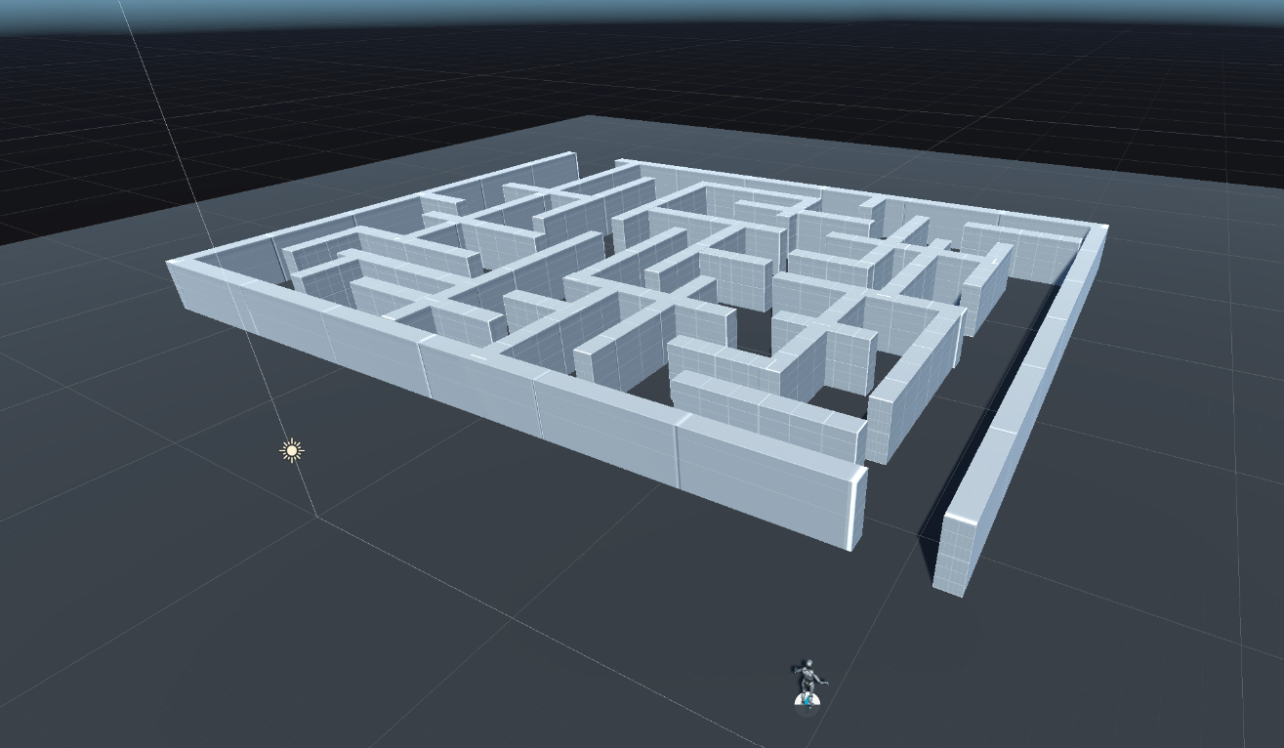

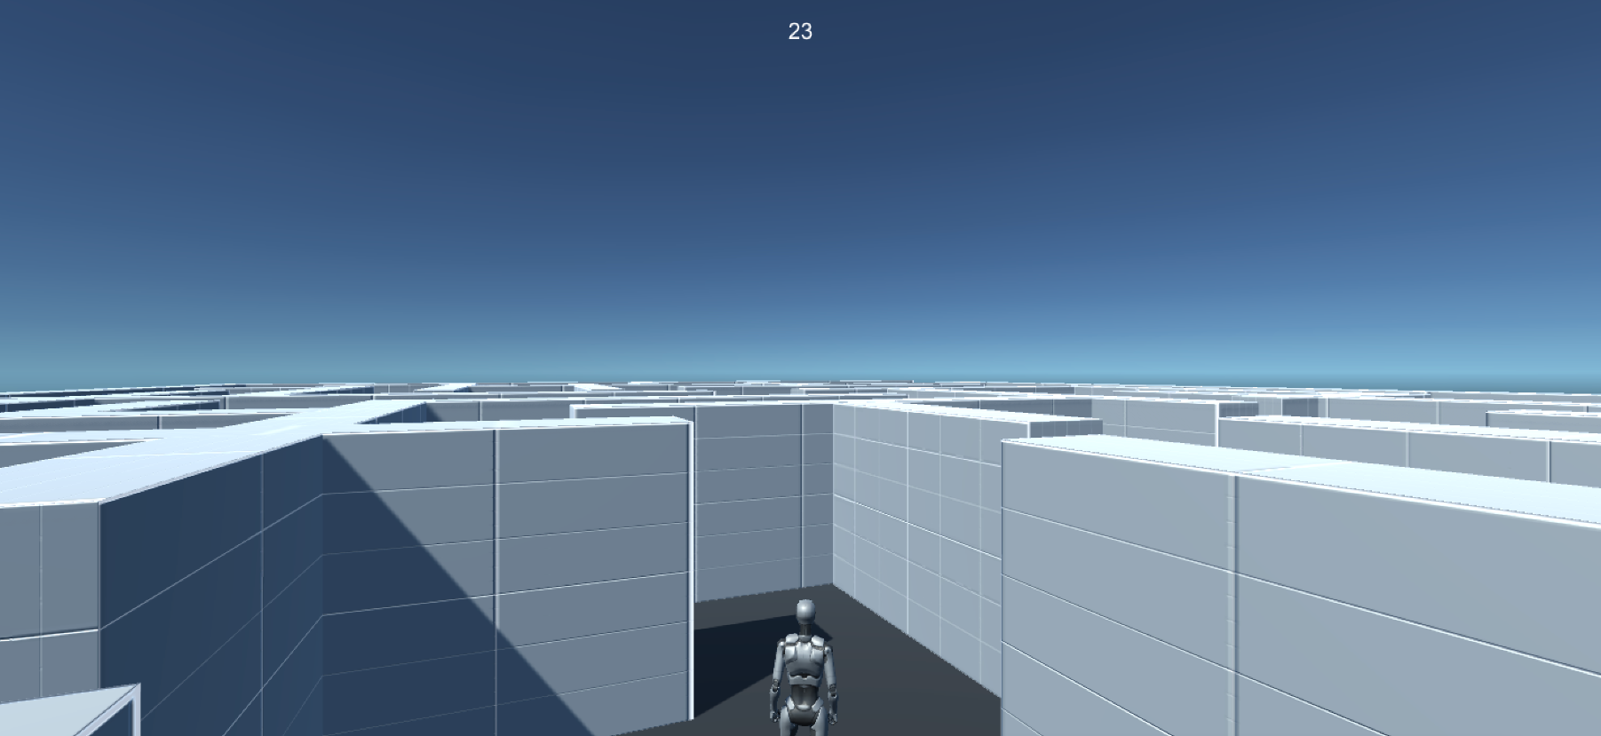



**Conclusion**

In conclusion, the development of a VR 3D pool game and a VR 3D maze game using Unity represents a significant step forward in harnessing the potential of virtual reality for immersive and entertaining gaming experiences. Both projects have been guided by a strong commitment to user experience design, recognizing that the success of a VR game lies in its ability to captivate players while ensuring ease of use.

Throughout the journey of conceptualization, design, and implementation, we've explored the intricacies of VR user experience, from spatial audio and hand-tracking to motion controls. These components have been seamlessly integrated to provide a heightened sense of realism and interactivity, making the games engaging and enjoyable. We've also addressed the unique challenges of translating real-world mechanics into the virtual realm, unlocking new dimensions of immersion for players.

In the realm of VR game development, Unity has proven to be an invaluable platform. Its tools and features have enabled us to create visually appealing and user-friendly environments that seamlessly blend with the VR experience. Furthermore, the iterative nature of user testing and feedback collection has been emphasized, underlining the importance of player input in refining the games for a seamless and thrilling experience.

In essence, these projects not only offer entertaining virtual experiences but also serve as showcases of how VR technology can breathe new life into traditional gaming concepts. The possibilities are boundless, and as the VR landscape continues to evolve, the potential for even more immersive and engaging gaming experiences is limitless. These endeavors mark a promising step forward in leveraging VR to create the future of interactive entertainment.